**Wireframe Document**

**Amazon Sales Data Analysis**



**Revision Number - 1.2**

**Last Date of Revision - 20/09/2022**

**Sikha Pandey**

# Document Control

|  |  |  |  |  |
| --- | --- | --- | --- | --- |
| **Date** |  | **Version** | **Description** | **Author** |
| 26/09/2022 | 1.0 |  | Introduction,  Problem Statement | Sikha Pandey |
| 10/10/2022 | 1.1 |  | Dataset Information,  Architecture  Description | Sikha Pandey |
| 16/10/2022 | 1.2 |  | Final Revision | Sikha Pandey |
|  |  |  |  |  |

**We Performed Exploratory Data Analysis on Jupyter Notebook and then created a Power BI Desktop Dashboard.**

1. **Top 10 high-profit items?**

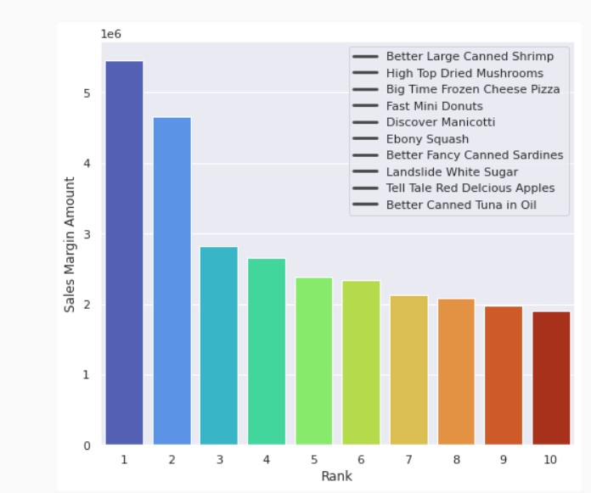

* According to the distribution the highest profit item is better large canned shrimp.

1. **Sales Distribution of each year?**

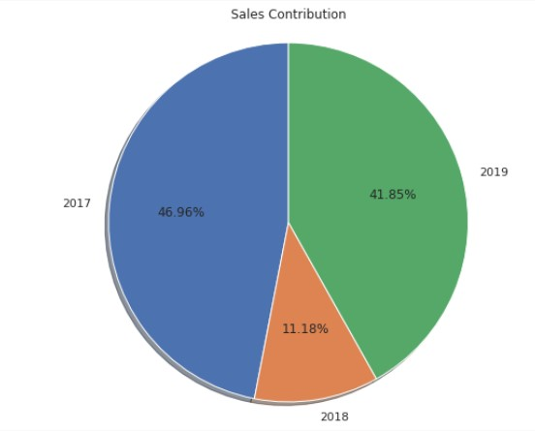

**. Yearly profit**

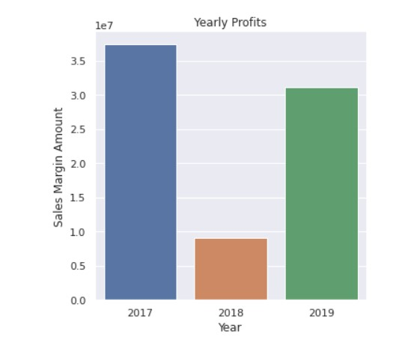

* 2017 has the most profit year.

1. **Top 10 days when the highest quantity was sold?**

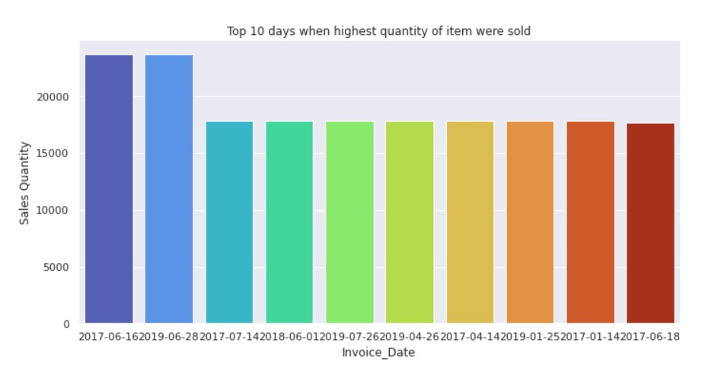

* On 16/06/2017 the highest number of items were sold.

**3. Top 10 customers?**

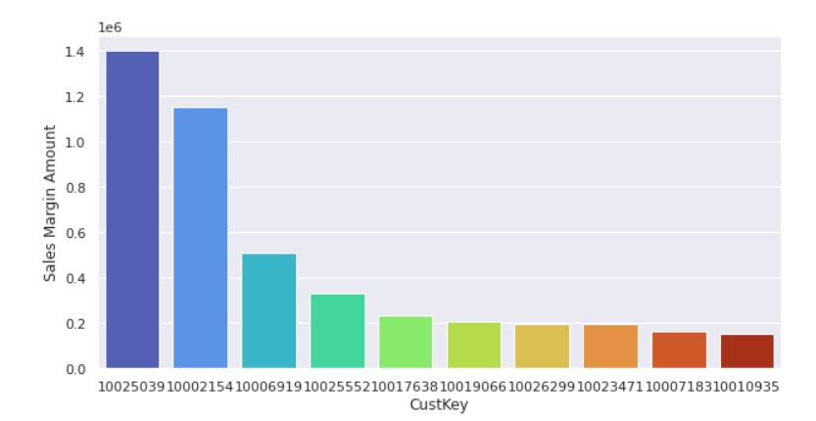

* **Customer with id number 10025039 bought the highest number of items.**

# Sales Report

